**SOFTWARE ENGINEERING REPORT**

**MIDTERM TEST**



**Member of Group :**

**Davis Maulana Hermanto (06)**

**Dicha Zeleanivan Arkana (08)**

**Ichsan Ali Darmawan (12)**

**Muhammad Baihaqi Aulia Asy’ari (18)**

**Yanuar Thaif Chalil Candra (28)**

**STUDY PROGRAM D-IV INFORMATICS ENGINEERING**

**INFORMATION TECHNOLOGY DEPARTMENT**

**STATE POLYTECHNIC OF MALANG**

**Soekarno Hatta Street No.9, Jatimulyo, Lowokwaru District, Malang City, East Java**

**65141**

**Step by Step**

Here we provide an explanation and also screenshots about our group work.

1. Firstly, we need to read all the case study
2. Determine the Actor(s) and Use case(s) using the textual analysis on visual paradigm
3. Next, fill the description in the table below
4. Change the highlight colour so we can easily understand the usage of each candidate class

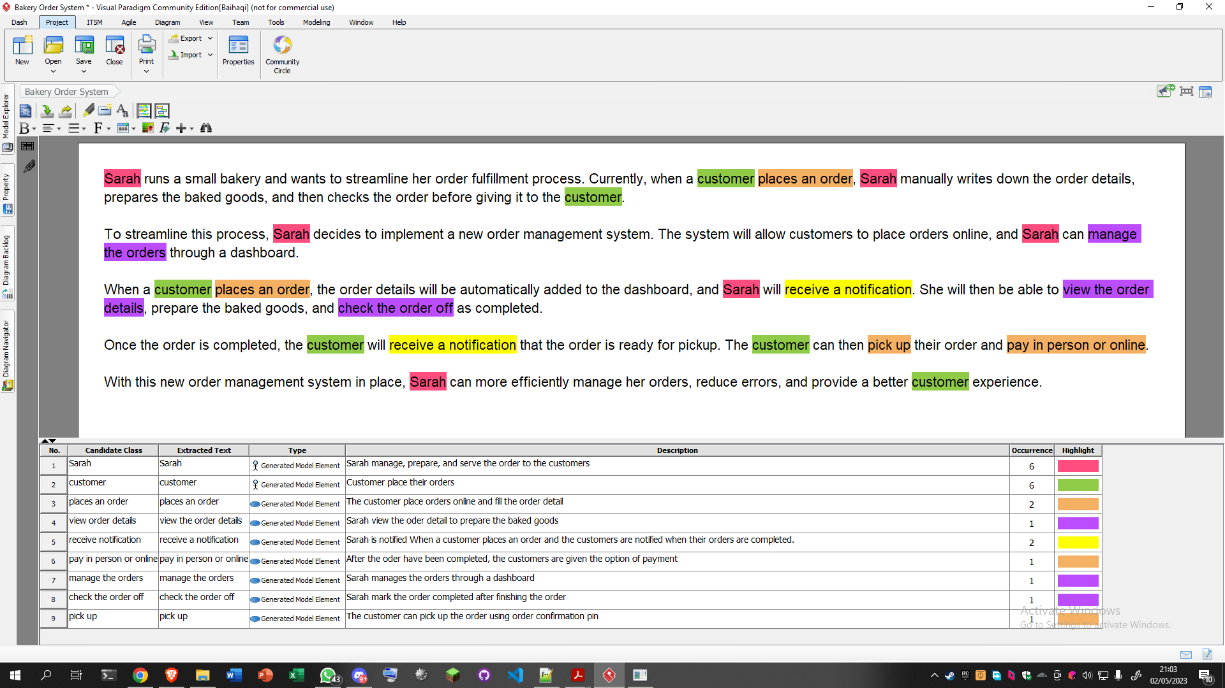

1. Select all the candidate class, then right-click to open the “create new use case diagram” button
2. Make the use case diagram as the picture below

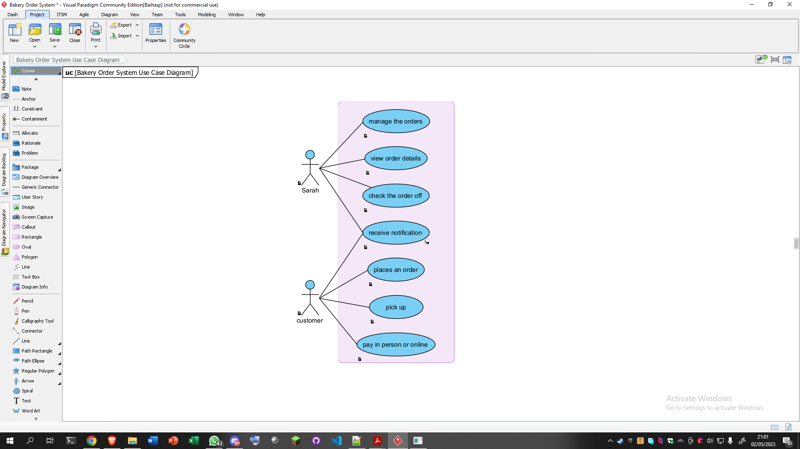

1. Right-click on receive notification use case, then select open specification
2. Make the use case specification as the table below

| Use Case Specification | |
| --- | --- |
| Use Case Name | Receive Notification |
| Actor(s) | Sarah, Customer(s) |
| Summary Description | Sarah is notified when customer place an order and the customer are notified when the order are completed |
| Priority | Must Have |
| Status | Medium level of details |
| Pre-condition | Customer placed an order or Sarah completed the order |
| Post-condition | Customer picked up and pay for the order |
| Basic Path | * Sarah or Customer received notification from app via the system * Sarah or Customer open the notification bar * Sarah or Customer clicked the notification of the app * Sarah or Customer opened the app * Sarah or Customer see the order is finished or placed |
| Alternative Path | * Sarah or Customer received notification from app via the system * Sarah or Customer opened the app * Sarah or Customer see the order is finished or placed |
| Exception Path | * Sarah or Customer removed the notification and forgot the order * Sarah or Customer is offline * Sarah or Customer’s App is force closed |

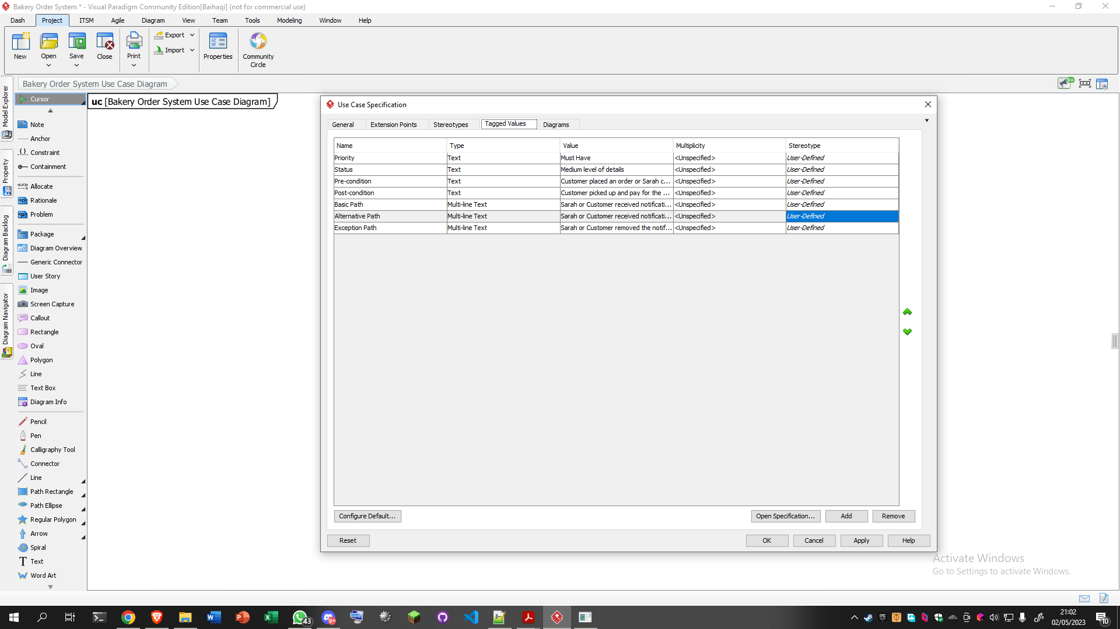

1. After that, right click on receive notification again, and select ￼open specification
2. Select the activity diagram
3. Make the activity diagram as the picture below

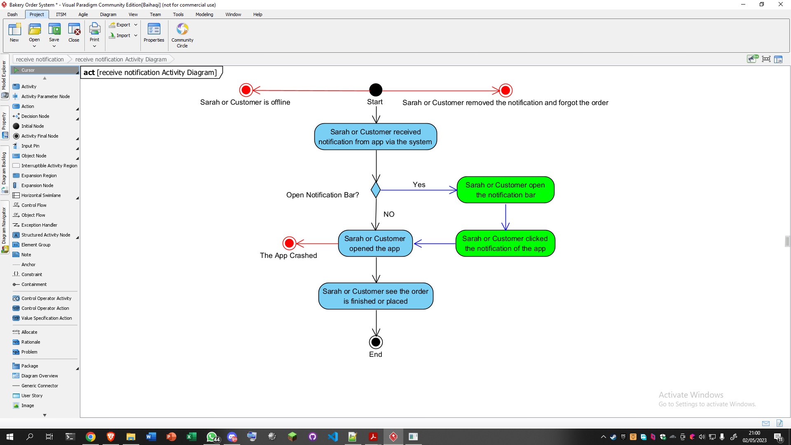

1. Well done, you’ve completed your tutorial section traveller, now your journey begins from here! Good luck!